

Semester Two Examination, 2022

Question/Answer booklet

MATHEMATICS METHODS
UNIT 3 & 4

Section One:

Calculator-free

Your Name:
Your Teacher’s Name:

Time allowed for this section
Reading time before commencing work: five minutes
Working time: fifty minutes

Materials required/recommended for this section
To be provided by the supervisor
This Question/Answer booklet
Formula sheet

To be provided by the candidate
Standard items: pens (blue/black preferred), pencils (including coloured), sharpener, correction fluid/tape, eraser, ruler, highlighters

Special items: nil

Important note to candidates
No other items may be taken into the examination room. It is your responsibility to ensure that you do not have any unauthorised material. If you have any unauthorised material with you, hand it to the supervisor before reading any further.

Question | Marks | Max | Question | Marks | Max
1 |  | 8 | 5 |  | 6
2 |  | 10 | 6 |  | 13
3 |  | 8
4 |  | 8

Structure of this paper

Section | Number of questions available | Number of questions to be answered | Working time (minutes) | Marks available | Percentage of examination
Section One:  Calculator-free | 6 | 6 | 50 | 49 | 35
Section Two:  Calculator-assumed | 10 | 10 | 100 | 100 | 65
 |  |  |  | Total | 100

Instructions to candidates

- The rules for the conduct of the Western Australian Certificate of Education ATAR course examinations are detailed in the Year 12 Information Handbook 2019. Sitting this examination implies that you agree to abide by these rules.

- Write your answers in this Question/Answer booklet.

- You must be careful to confine your answers to the specific questions asked and to follow any instructions that are specific to a particular question.

- Additional pages for the use of planning your answer to a question or continuing your answer to a question have been provided at the end of this Question/Answer booklet. If you use the space to continue an answer, indicate in the original answer space where the answer is continued, i.e. give the page number.

- Show all your working clearly. Your working should be in sufficient detail to allow your answers to be checked readily and for marks to be awarded for reasoning. Incorrect answers given without supporting reasoning cannot be allocated any marks. For any question or part question worth more than two marks, valid working or justification is required to receive full marks. If you repeat any question, ensure that you cancel the answer you do not wish to have marked.

- It is recommended that you do not use pencil, except in diagrams.

- The Formula sheet is not to be handed in with your Question/Answer booklet.

Section One: Calculator-free (49 marks)

This section has six questions. Answer all questions. Write your answers in the spaces provided.

Spare pages are included at the end of this booklet. They can be used for planning your responses and/or as additional space if required to continue an answer.
● Planning: If you use the spare pages for planning, indicate this clearly at the top of the page.
● Continuing an answer: If you need to use the space to continue an answer, indicate in the original answer space where the answer is continued, i.e. give the page number. Fill in the number of the question that you are continuing to answer at the top of the page.

Working time: 50 minutes.

Question 1 (5 marks)

The graph with equation $y=k{\left(2x-4\right)}^{3}$ is shown below.

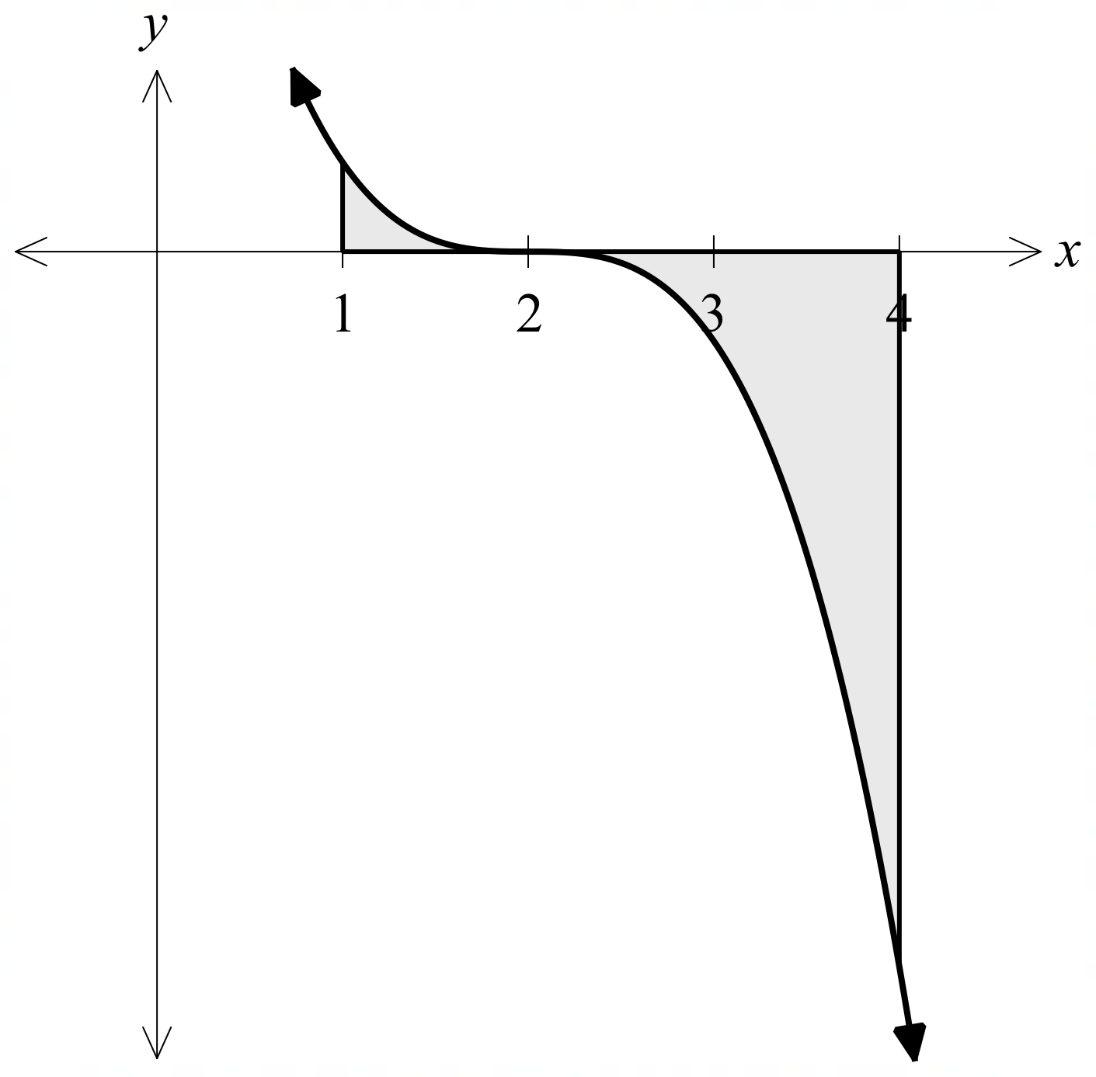

If the area of the shaded region is $17 {units}^{2}$, determine the value of $k$.

Solution
$$\int_{1}^{2}{k{\left(2x-4\right)}^{3}dx}-\int_{2}^{4}{k{\left(2x-4\right)}^{3}dx}=17$$

$$k\left({\left[\frac{{\left(2x-4\right)}^{4}}{8}\right]}_{1}^{2}-{\left[\frac{{\left(2x-4\right)}^{4}}{8}\right]}_{2}^{4}\right)=17$$
$$k\left(\left(0-2\right)-\left(32-0\right)\right)=17 \\ -34k=17$$
$$k=-\frac{1}{2}$$

Specific behaviours
- Writes at least one definite integral to determine area.
- Recognises that the area from
$x=2$ to $x=4$ is a signed area, and deals with this correctly.
- Correctly integrates using chain rule.
- Correctly substitutes boundaries and simplifies.
- Determines the value of $k$.

Question 2 (10 marks)

A random experiment can either result in a success with a probability of $p$ or a failure.

In an event, this random experiment is conducted twice. Each experiment is independent of the other. Let the number of successes be represented by $X$.

(a) State the distribution, and its parameters, that can be used to model the event described above. (2 marks)

Solution
$$X\sim Bin(2,p)$$

Specific behaviours
- Identifies the distribution as binomial.
- Writes down the correct parameters. .

The graph below shows of the variance for the distribution in part (a) for various values of $p$.

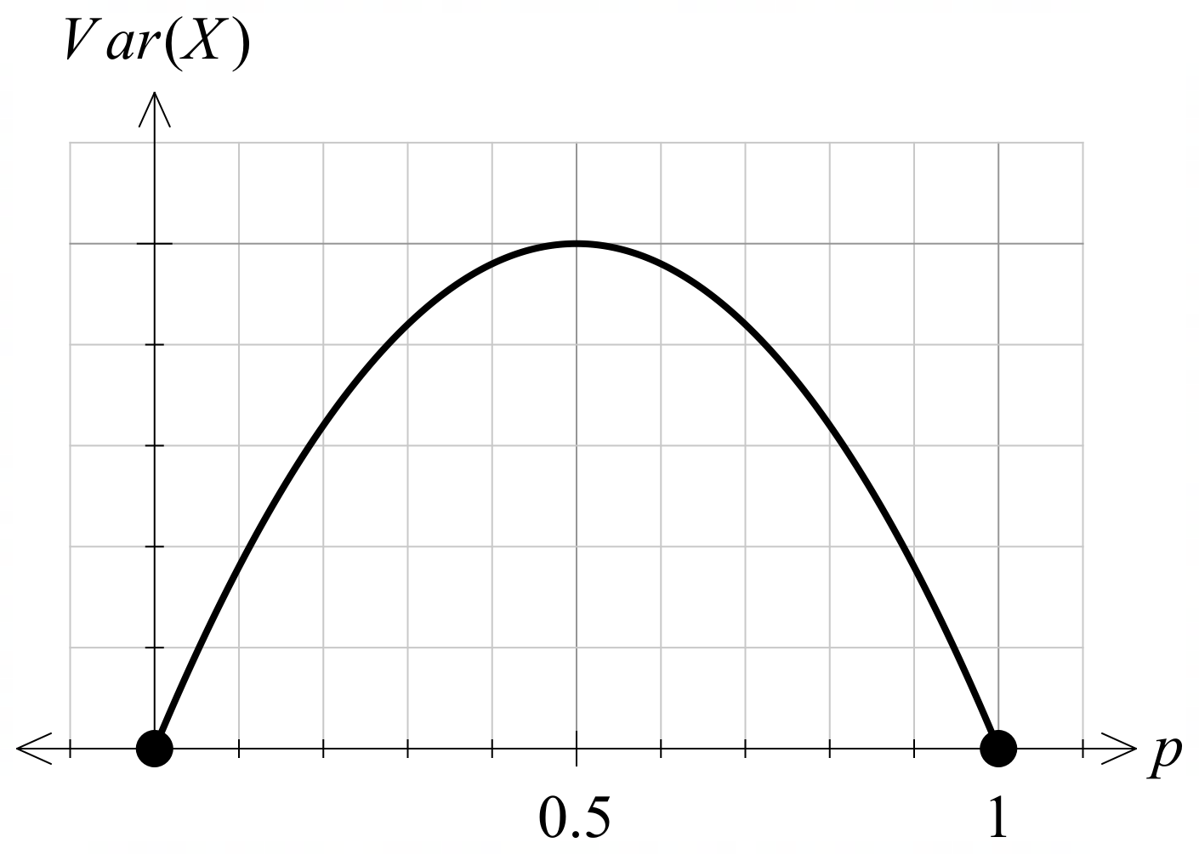

(b) Explain why the graph is continuous, despite the distribution being discrete. (1 mark)

Solution
The probability is any value between $0$ and $1$, and hence the graph is continuous.

Specific behaviours
P Explains why the graph is continuous.

(c) (i) State the value of $p$ for which the standard deviation of $X$ is maximised. (1 mark)

Solution
$$p=0.5$$

Specific behaviours
P States value of $p$.

(ii) Hence determine the exact value of the standard deviation, for the value of $p$
in part (c)(i). (1 mark)
Solution
$$Var\left(X\right)=2×0.5×0.5=0.5$$
$$SD\left(X\right)=\frac{1}{\sqrt{2}}$$

Specific behaviours
P Determines standard deviation

For the distribution in part (a), the probability that at least one of these experiments results in a success is $0.51$.

(d) (i) Show that ${\left(1-p\right)}^{2}=0.49$ (2 marks)

Solution
$$P\left(X=0\right)=1-0.51$$
$${\left(1-p\right)}^{2}=0.49$$

Specific behaviours
P Uses complement to $P(X≥1)$.
PShows that $P\left(X=0\right)={\left(1-p\right)}^{2}$.

(ii) Hence show that the value of $p$ is $0.3$. (1 mark)

Solution
$$1-p=0.7$$
$$p=0.3$$

Specific behaviours
P Correctly square roots $0.49$ and determines $p$.

(e) Determine $E(X)$ for this distribution. (1 mark)

Solution
$$E\left(X\right)=0.6$$

Specific behaviours
P Correctly determines expected value.

A second random variable $Y$ is defined as $Y\sim B(2, 0.7)$.

Given that $Var\left(X\right)=0.42$.

(f) Explain why $Var\left(Y\right)=Var(X)$. (1 mark)

Solution
The distribution of $Y$ is a reflection of $X$.

Specific behaviours
P Explains using a reflection.

Question 3 (10 marks)

(a) Determine whether the following represent or do not represent a probability distribution. Justify each answer.
(i) 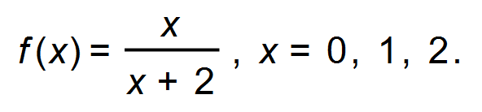 (1 mark)

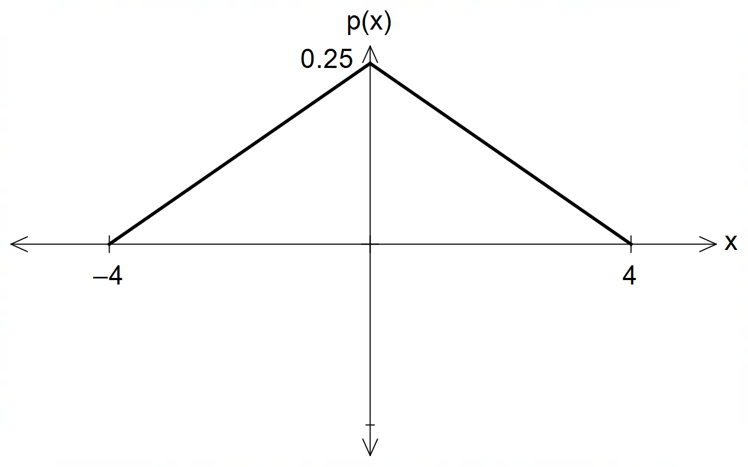(ii) (1 mark)

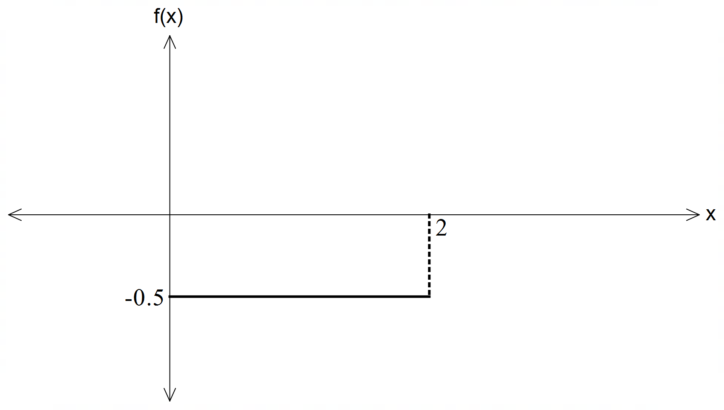
(iii) (1 mark)

Solution
(i) Not a probability distribution, sum of probabilities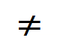1
(ii) Does represent a probability distribution;
Area = 1 and p(x) is always positive
(iii) Not a probability distribution. f(x) < 0 (negative)

Specific behaviours
P explains above for (i)
P explains above for (ii)
P explains above for (iii)
b) A probability distribution of a random variable X is given by
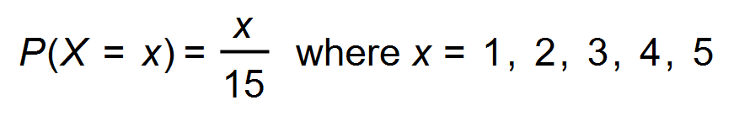 .

(i) Graph the probability function on the axes below. (2 marks)

Solution
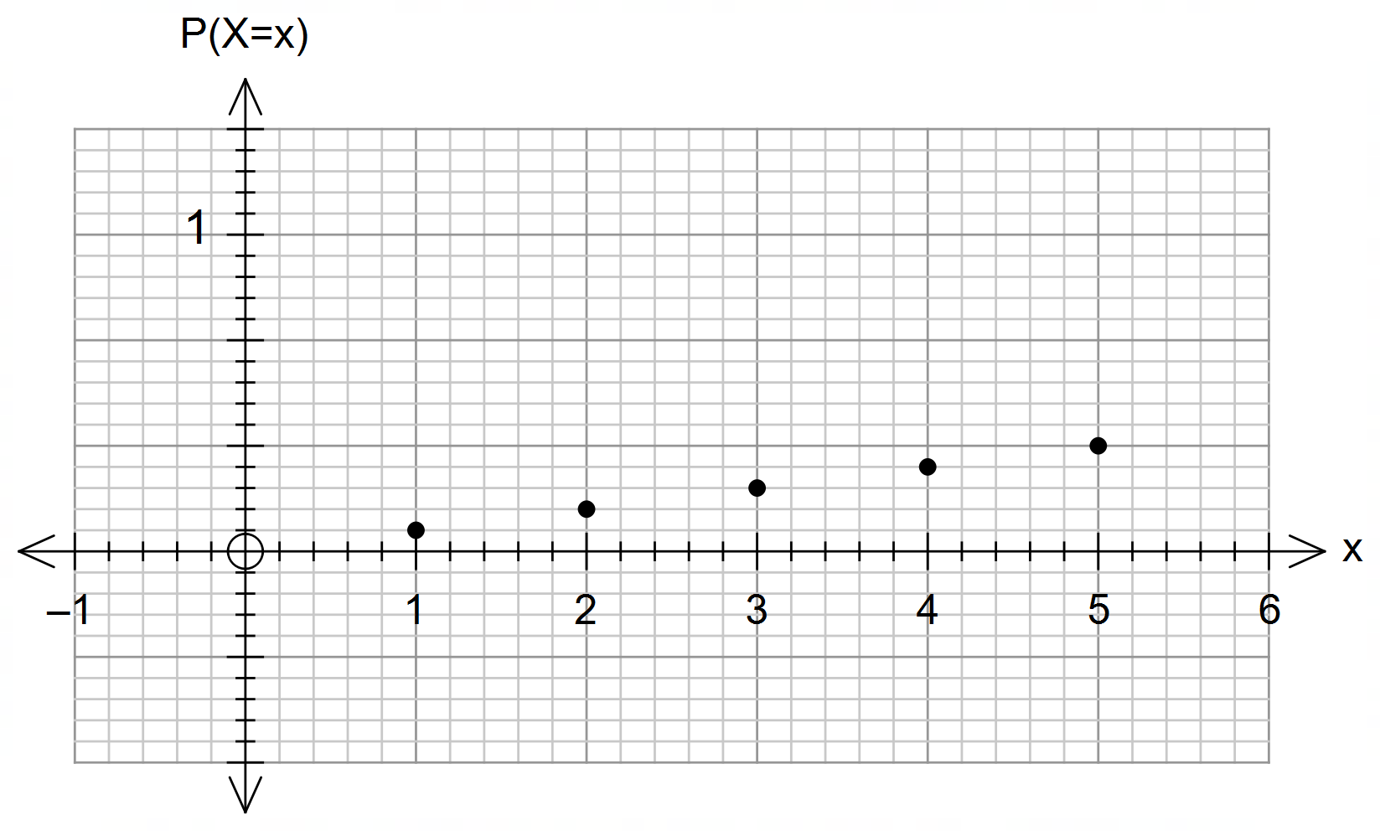

Specific behaviours
P plots two dots correctly
P plots all dots correctly

(ii) Determine the probability of obtaining a value of X less than 3. (1 mark)

Solution
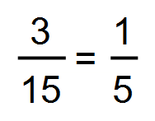

Specific behaviours
P determines prob

(iii) Determine 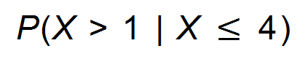. (2 marks)

Solution
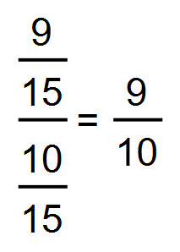

Specific behaviours
P numerator
P denominator

(iv) State the cumulative probability distribution for X. (2 marks)

Solution
x | 1 | 2 | 3 | 4 | 5
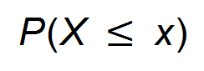 | 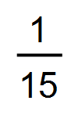 | 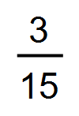 | 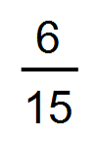 | 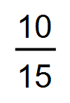 | 1

Specific behaviours
P determines at least two correct probs
P all probs correct

Question 4 (8 marks)
Determine the following:

(a) $\int{6e^{2x-3}}dx$. (1 mark)

Solution
$$3e^{2x-3}+c$$

Specific behaviours
P correct antiderivative, with constant of integration

(b) $\int_{0}^{\frac{π}{8}}{\underset{ }{\overset{ }{\sin{(4x)}}}}dx$. (2 marks)

Solution
$${\left[-\frac{1}{4}\cos{(4x)}\right]}_{0}^{π/8}=0-\left(-\frac{1}{4}\right)=\frac{1}{4}$$

Specific behaviours
P correct antiderivative
ü correct value

(c) $f^{'}\left(\begin{matrix}π \\ \overline{6}\end{matrix}\right)$ when $f\left(x\right)=\begin{matrix}\cos{(3x)} \\ \overline{2+\sin\left(x\right)}\end{matrix}$. (3 marks)

Solution
$$f^{'}\left(x\right)=\frac{-3\sin\left(3x\right)\left(2+\sin\left(x\right)\right)-\cos\left(3x\right)\cos\left(x\right)}{{\left(2+\sin\left(x\right)\right)}^{2}} \\ f^{'}\left(\frac{π}{6}\right)=\frac{-3\left(2+0.5\right)-0}{{\left(2+0.5\right)}^{2}} \\ =-\frac{3}{2.5}=-\frac{6}{5}$$

Specific behaviours
P correctly uses quotient rule
ü correctly differentiates all trig terms
ü correctly evaluates

(d) $\begin{matrix}d \\ \overline{dx}\end{matrix}\int_{1}^{x}{\underset{ }{\overset{ }{\cos\left(t+1\right)}}}dt$. (1 mark)

Solution
$$cos⁡(x+1)$$

Specific behaviours
P correct result

(e) $\int_{0}^{3}{\begin{matrix}d \\ \overline{dx}\end{matrix} \left(x e^{2x}\right)}dx$. (1 mark)

Solution
$${\left[xe^{2x}\right]}_{0}^{3}=3e^{6}$$

Specific behaviours
P correct result

Question 5 (8 marks)
Components A and B form part of an electronic circuit, and properties of these components are measured $t$ seconds after the circuit is turned on.

(a) The rate of change of temperature, $T ℃$, of component A is given by $\begin{matrix}dT \\ \overline{dt}\end{matrix}=\begin{matrix}18t \\ \overline{{3t}^{2}+8}\end{matrix}$. Determine, in simplest form, the increase in temperature of this component during the first $4$ seconds. (4 marks)

Solution
$$ΔT=\int_{0}^{4}{\frac{18t}{{3t}^{2}+8}}dt \\ =3\int_{0}^{4}{\frac{6t}{{3t}^{2}+8}}dt \\ =3{\left[\ln\left(3t^{2}+8\right)\right]}_{0}^{4} \\ =3\left(\ln\left(56\right)-\ln\left(8\right)\right) \\ =3\ln\left(7\right) ℃$$

Specific behaviours
P writes integral to evaluate total change
ü integrates rate of change
ü substitutes limits of integral
ü correct increase, simplified (also accept $\ln{(343)}$)

(b) The current, $I$ amps, flowing through component B reaches a peak very quickly and then declines as time goes on, as modelled by $I\left(t\right)=\begin{matrix}2+\ln\left(t\right) \\ \overline{ \overset{ }{4t} }\end{matrix}$. Determine, in simplest form, the maximum current that flows through this component. (4 marks)

Solution
$$I'(t)=\frac{\left(\frac{1}{t}\right)\left(4t\right)-\left(2+\ln{t}\right)\left(4\right)}{{\left(4t\right)}^{2}} \\ =\frac{4-4\left(2+\ln{t}\right)}{4×4t^{2}} \\ =\frac{-1-\ln{t}}{4t^{2}}$$

$$I^{'}\left(t\right)=0⇒\ln{t}=-1 \\ t=e^{-1}$$

$$I\left(e^{-1}\right)=\frac{2-1}{4e^{-1}}=\frac{e}{4}$$

Maximum current is $\begin{matrix}e \\ \overline{4}\end{matrix}$ amps.

Specific behaviours
P uses quotient rule
ü obtains correct derivative and equates to zero
ü obtains root of derivative
ü calculates maximum current in simplified form

Question 6 (8 marks)
Let $f\left(x\right)=k\log_{6}{(x+6)}+c$, where $k$ and $c$ are constants.

The graph of $y=f(x)$ intersects line $L$ with equation $5y+2x+15=0$ when $x=0$ and $x=-5$.

(a) Determine the value of the constant $c$ and the value of the constant $k$. (3 marks)

Solution
$$x=0, y=-\frac{0+15}{5}=-3, x=-5, y=-\frac{-10+15}{5}=-1$$

Using $(-5, -1)$: $-1=k\log_{6}\left(1\right)+c→c=-1$

Using $(0, -3)$: $-3=k\log_{6}\left(6\right)-1→k=-2$

Specific behaviours
P calculates two points on curve (Must state paired coords)
ü value of $c$
ü value of $k$

(b) Sketch the graph of $y=f(x)$ on the axes below. (3 marks)

Solution
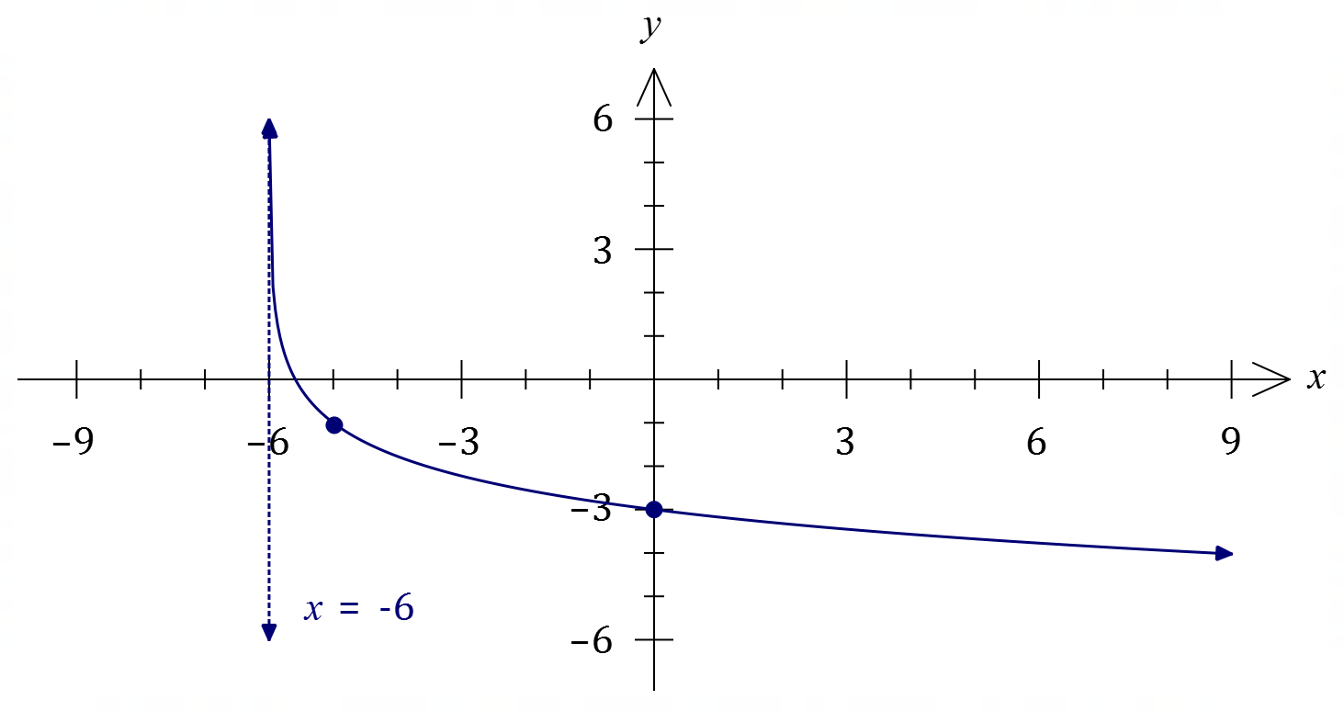

Specific behaviours
ü through two points from (b)
ü asymptote, correct curvature nearby
ü smooth curve, concave up throughout

(c) Given that $\log_{6}{(x+6)}=\begin{matrix}\ln{(x+6)} \\ \overline{ \ln{\overset{ }{\left(6\right)} }}\end{matrix}$, determine the value of $x$ where the slopes of $y=f(x)$ and line $L$ are the same. (2 marks)

Solution
$$f\left(x\right)=-2\log_{6}\left(x+6\right)-1=\frac{-2}{\ln\left(6\right)}\ln\left(x+6\right)-1$$
$$f^{'}(x)=\frac{-2}{\ln\left(6\right)}×\frac{1}{x+6} \\ \frac{-2}{\ln\left(6\right)}×\frac{1}{x+6}=\frac{-2}{5}→x=\frac{5}{\ln\left(6\right)}-6$$

Specific behaviours
P correctly differentiates $f$
ü solves for $x$-coordinate and fully simplified
Note- no follow through if mistake makes solving too easy

End of questions

